**Homework 6 Solution**

1. Find a solution, by hand, to the congruence $1234x≡123 (mod 4321).$

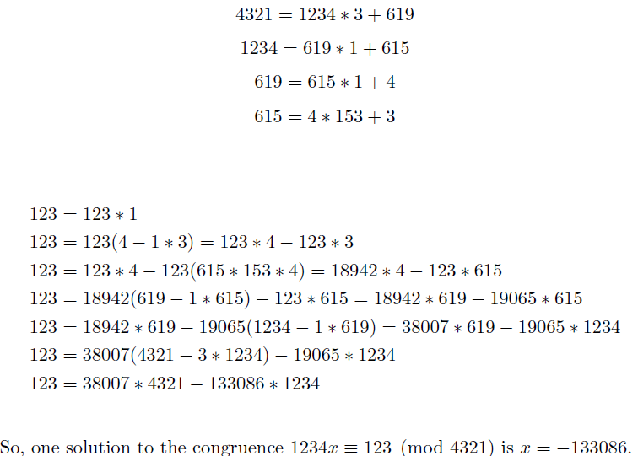

1. a. Considering $a=5$ as an element of $Z_{11}^{*}$ (the invertible elements mod 11), find $a^{-1}$.

The inverse of 5 modulo 11 is 9 because $9⋅5=45≡1 (mod 11)$.

b. Considering $a=5$ as an element of $Z_{12}^{*}$ (the invertible elements mod 12), find $a^{-1}$.

The inverse of 5 modulo 12 is 5 because $5⋅5=25≡1 (mod 12)$.

1. Is $ϕ(n)$ (can’t get the right phi to show up) even for every *n*>2? If so, justify why. If not, give a counterexample.

If $1≤a≤n-1$ is relatively prime to *n,* then *n-a* is also relatively prime to *n.* So we can pair each *a* with the corresponding *n-a*. The only case we have to consider is the possibility of $a=n-a,$ which cannot happen because then *n* and *a* cannot be relatively prime. So we have an even number of relatively prime *a*’s.

(Once we learn the formula for the general ϕ(*n*) later, we can do the problem using that as well.)

1. Find all solutions in $Z_{68}$ to the equation $12x≡20 (mod 68).$

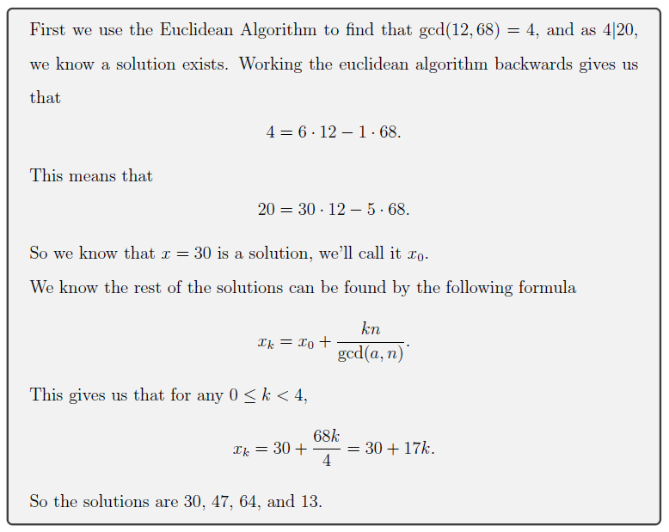

1. Prove the next-to-last corollary on page 2 of the class activity (If gcd(a, n) = 1 and ax ≡ ab (mod n), then x ≡ b (mod n)) directly, without using Theorem 1 or its corollaries.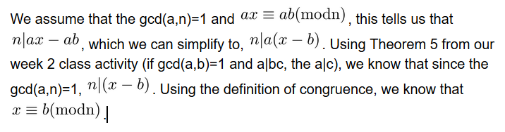
2. Find a complete residue system modulo 5 composed entirely of multiples of 9.
3. Write a code to find the inverse of a given number *a* mod *n.* Your code should give an error if there is no inverse. (If possible, use an efficient algorithm.)

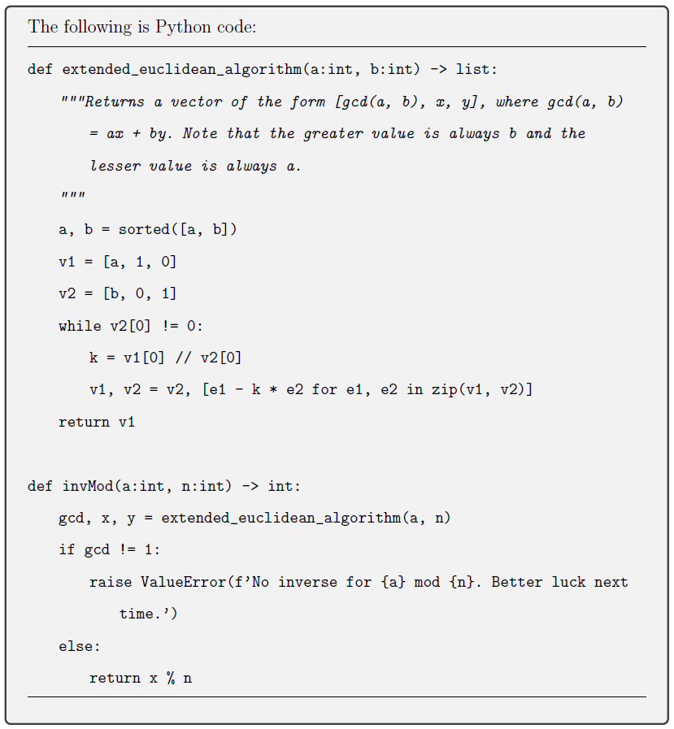

If you’d like a shorter code:

